
Term Project Document
- Project Title: Cricket Performance Predictor using ML (Batting)

- Submitted by:

  - Name: Imad Khan
  - Sap ID: 70136085
  - Contact: 03044011922

  - Name: Shahiryar Ahmed
  - Sap ID: 70136052
  - Contact: 03000840695

  - Name: Arooj Fatima
  - Sap ID: 70136139
  - Contact: 03260886903

Cricket Performance Predictor Using Machine Learning (Batting)

Abstract:
Cricket performance prediction plays an important role in modern sports analytics by helping teams and analysts make informed decisions. This project focuses on predicting a cricket player’s batting performance using machine learning techniques. Historical batting data such as runs scored, strike rate, number of matches, and other relevant features are collected and preprocessed to ensure accuracy and consistency. Different machine learning models are trained and evaluated to identify patterns and trends in batting performance. The system aims to predict future batting outcomes based on past performances. The results show that machine learning can effectively analyze cricket data and provide meaningful predictions, which can assist selectors, coaches, and analysts in performance evaluation and strategic planning.

Tentative Algorithms / Tools:
Algorithms:
- Linear Regression
- Decision Tree
Tools & Technologies:
- Python
- Pandas (for data handling and Analysis)
- NumPy (for numerical computations)
- Matplotlib / Seaborn (for data visualization and advance graph)
- Scikit-learn (for machine learning models)
Dataset Sources:
- Public cricket datasets (e.g., player batting statistics from online repositories)

Expected Outcomes:
- The system will analyse past batting data of cricket players.
- It will predict future batting performance based on previous records.
- The project will show how machine learning can be used in cricket analysis.
- The model will help in understanding player consistency and form.
- The results can support better decision-making for team selection and strategy.
Problem Formulation:
The goal of this project is to predict a cricket player’s batting performance using historical data. The problem is defined as a supervised machine-learning regression task, where the model learns relationships between input features and the batting outcome.
Input features may include:
- Player Name
- Opposition team
- Balls faced
- strike rate
Output (target variable):
- Predicted runs in the next match
The objective is to minimize prediction error while identifying patterns that describe player consistency and performance trends. This helps coaches and analysts make better decisions regarding team selection and strategy.
Existing Solutions:
Several existing systems and research work focus on using data analytics and machine learning to analyze and predict cricket performance. Most of these solutions rely on historical match statistics to identify trends in player form and match outcomes.
1. Statistical Cricket Analysis Tools
Traditional cricket analysis platforms (such as ESPN Cricinfo StatsGuru (https://stats.espncricinfo.com/ci/engine/stats/index.html ) and Cricbuzz analytics pages) provide:
- Player averages and strike rates
- Performance against specific teams and venues
- Comparisons between players
However, these systems mainly present descriptive statistics. They do not perform predictive modelling and cannot estimate future performance automatically.

2. Machine Learning–Based Research Studies
Recent academic studies have applied machine learning to cricket, focusing on:
- Match outcome prediction
- Player ranking and performance evaluation
- Fantasy league recommendation systems
Many studies use algorithms such as Linear Regression, Random Forests, Support Vector Machines, and Neural Networks. While these approaches show promising accuracy, most research remains experimental and is not implemented as user-friendly tools.

3. Sports Analytics Platforms
Some advanced sports analytics companies (mainly in football and baseball) provide AI-based performance prediction systems. However, similar platforms for cricket are still limited, expensive, or not openly available to students and researchers.
Proposed solution:
The proposed solution is to build a machine-learning-based system that predicts a cricket player’s future batting performance using historical match data. The system follows a structured framework consisting of data collection, preprocessing, feature engineering, model training, evaluation, and prediction.
Implementation / Experiments:
The implementation followed these major steps:
- Data Collection:
Public cricket datasets were collected from online repositories containing player batting statistics.
- Data Preprocessing:
  - Handling missing values
  - Encoding categorical features (e.g., teams, venues)
  - Normalizing numerical values where needed
  - Splitting the data into training and testing sets
- Model Development:
Two models were implemented:
  - Linear Regression — to understand linear trends in batting performance
  - Decision Tree Regressor — to capture non-linear relationships and feature interactions

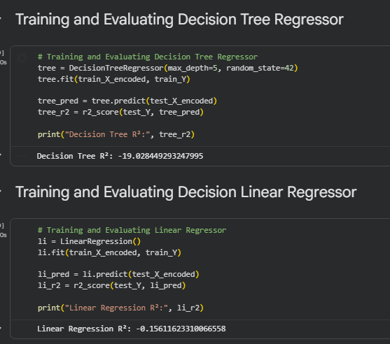
Both models were trained using Scikit-learn.
- Evaluation
Models were evaluated using:
  - R² score
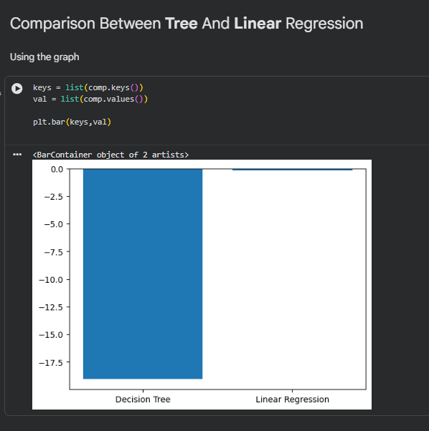
Performance was compared to determine which model predicts more accurately.
- Visualization
Matplotlib and Seaborn were used to visualize:
  - Actual vs. predicted runs
  - Feature distributions
  - Model comparison graphs

Results:
The experiments show that machine learning can successfully analyze batting patterns and provide reasonable predictions based on past performance.
Key observations:
- The models detected meaningful relationships between features such as balls faced, previous runs, and match history.
- Linear Regression performed better than the Decision Tree model and produced more accurate predictions for batting performance in this project.
- Predictions are useful for identifying players who are consistent or likely to perform well under certain conditions.
Overall, the results confirm that data-driven techniques can support cricket analysts and selectors in performance evaluation and decision-making.

Conclusion:
The project demonstrates how machine learning can be applied effectively to cricket analytics, specifically for predicting batting performance. By cleaning and analyzing historical player data and training models such as Linear Regression and Decision Trees, the system can identify patterns in player form and consistency. These predictions can assist coaches, analysts, and selectors in making better decisions about strategy and team selection. Overall, the project shows that data-driven approaches can add real value to sports performance evaluation and future planning.
References:
Cricket prediction Batting performance: - IPL - Player Performance Dataset
Scikit Learn: - https://scikit-learn.org/stable/
Pandas Library: - https://pandas.pydata.org/
Seaborn Library: - https://seaborn.pydata.org/
Matplotlib pyplot: - https://www.w3schools.com/python/matplotlib_pyplot.asp
NumPy Library: - https://www.w3schools.com/python/numpy/numpy_intro.asp


